**Assignment 3**

**CREATE TABLE Users(**

**roll_ number long, username varchar(255),email varchar(255),password varchar(255)**

**);**

**INSERT INTO users(roll_ number, username, gmail, password)VALUES**

**(73151913034,JAYAVELU,jayavelu@gmail.com,12345),**

**(73151913029,HARIHARAN,hariharan@gmail.com,12345),**

**(73151913040,KARTHI,karthi@gmail.com,12345),**

**(73151913012,BERINLUKE,berin.5@gmail.com,12345);**

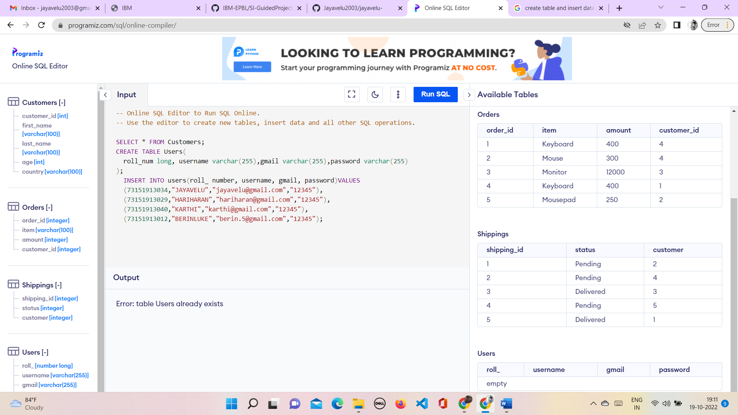

**OUTPUT:**

